Title: “Artificial Analysis: The Evaluation of AI Capabilities vs. Human Decision-Making in Business Think Tanks.”
Author: Killian Glavin

Abstract:
The adoption of Artificial intelligence (AI) in business has surged over the past 24 months, with 79% of organisations integrating it across functions (McKinsey & Company, 2025). This growth has contributed to widespread workforce displacement, with AI-attributed layoffs surpassing 54,000 in 2025 (Kaput, 2025). This study examines AI's current capabilities to support business-oriented decision-making in business think tanks scenarios and evaluates the extent to which large language models (LLMs) can replicate the analytical outputs of human participants. Primary data derives from a structured focus group of eleven undergraduate and postgraduate students, whose responses to three business decision-making scenarios are compared against outputs from four LLMs: ChatGPT, Gemini, Perplexity and Claude. Responses are evaluated across four metrics: originality, usefulness, divergence and convergence, using a standardised 1-3 scoring rubric. Each scenario was administered across three prompt variants, informal, neutral and formal. This was done to assess how sensitive each model was to framing and if that affects the output quality. Findings indicate that all four AI models scored below the midpoint on originality and usefulness, with limited response variation compared to human participants, suggesting LLMs are not yet suitable for use in think tank engagements.

MS5131- Major Project: Table of Contents
Abstract: 1
Introduction: 2
Literature Review: 3
AI Integration at the Organisational Level: 3
LLMs in Decision-Making: 4
Evaluating Human-AI Performance: 4
AI Think Tank Frameworks: 5
Convergence vs. Originality in AI Models: 5
Data and Research Methodology: 6
Hypothesis: 6
Research Design: 7
Research Questions: 7
Participants: 7
Data Collection: 8
Focus Group Protocol: 8
Question and Scenario Design: 8
Variant Dimensions: 9
Data Analysis: 9
Analytical Framework: 10
Supplementary Metrics: 10
Ethical Considerations: 10
Results: 11
Overview and Hypothesis: 11
AI Model Response Groups: 11
Discussion: 18
Response Alignment with Human Outputs: 19
Bias in AI Outputs: 19
Mid-Testing Shifts (Divergence Scores): 20
Prompt Sensitivity: 20
Comparative Performance: 21
Limitations: 21
Recommendations: 22
Conclusion: 22
Bibliography: 23
Appendix A: Prompt Scenarios 25
Appendix B: Grading Rubrics 28
Appendix C: Graded Tables AI Models 30
Appendix D: Mean Average Tables 35

Introduction:
The central problem this study investigated was LLMs current capabilities to support business-oriented decision-making in business think tanks. The value of these organisations lies in the quality and originality of their analysis. As generative AI becomes embedded in business operations, think tank organisations face a pressing question: could AI deliver outputs that meet the standards required for business-oriented decision-making?
The pace of AI adoption across business functions accelerated sharply since 2023, driven largely by the public release of accessible large LLMs. OpenAI's ChatGPT reached 100 million users within two months of launch (Hu, 2023), a rate of adoption unprecedented in enterprise technology. By 2025, generative AI has moved from an experimental tool to operational infrastructure in many private sector organisations, with applications spanning customer service chatbots, creating marketing content and automating financial admin (Halladay and Hanna, 2025).
Despite the rate in which AI has become incorporated into business there is little research into how think tanks have been impacted. This study quantified how effective LLMs were for business-oriented decision-making. This was done by comparing the responses of a focus group of undergraduate and postgraduate students to typical think tank tasks against four popular LLMs: ChatGPT, Gemini, Perplexity and Claude. Each LLM response was graded on originality, usefulness, convergence and divergence.

Literature Review:

AI Integration at the Organisational Level:
Despite the proliferation of LLMs across the corporate sector, literature has only recently begun to address the specific structural and qualitative implications of AI integration within high-level analytical environments like think tanks. At the organisational level, Hyiamang and Liu (2025) demonstrated through an eleven-firm multi-case study that AI integration delivered measurable gains in efficiency, forecast accuracy and revenue growth, although these benefits were contingent on strong leadership and data governance. For think tanks, whose authority rested on analytical credibility, this conditionality was significant. Due to this any AI adoption without appropriate oversight risks undermining the quality of outputs instead of enhancing them.

LLMs in Decision-Making:
The broader case for AI in decision-making was supported by Zuiderwijk, Chen and Salem (2021), whose systematic review of AI in public governance documented the conditions under which AI enhances decision-making, including improving forecast accuracy and processing complex information. Critically, they found that AI adoption in the public sector has lagged compared to the private sector, a gap they attribute to the unique accountability, transparency and public value requirements of government. This suggests that business-oriented organisations such as think tanks operating under less constraints, were likely integrating AI into analytical workflows considerably faster than the governance literature reflected, reinforcing the timeliness of the present study's focus on analytical output analysis.

Evaluating Human-AI Performance:
Lai et al. (2023) surveyed over one hundred empirical studies, examining study design choices across decision tasks, AI assistance elements and evaluation metrics. They identified decision quality, accuracy and reliance as recurring evaluative constructs and noted bias as a persistent concern in high-stakes domains for evaluation of AI. While they also observed that artificial tasks offer experimental control while cautioning against uncritical generalisation. The paper's domain breakdown suggests Finance & Business is comparatively under-represented relative to Law & Civic and Medicine & Healthcare, supporting the present study's context and design.
Steyvers and Kumar (2023) extended this by introducing the concept of complementarity, defined as outcomes in which human-AI collaboration exceeded what either could achieve independently. Their analysis identified the degree of correlation between human and AI reasoning as the critical limiting factor. Here AI predictions closely mirrored human judgement, the informational overlap reduced the potential for collaboration to add value beyond what either could produce alone. Complementarity was therefore most achievable where humans and AI brought distinct reasoning processes to the same problem. This finding carries direct implications for the present study. Extending on Steyvers and Kumar's framework, it raises the question of whether LLMs, trained on human-generated data are therefore structurally inclined toward human-like reasoning patterns and whether they can offer the independent analytical contribution that complementarity requires.

AI Think Tank Frameworks:
The question of whether AI could replicate specialist advisory functions was directly addressed by Sorooshian (2025), who proposed an AI Think Tank (AITT) framework, this a four-stage process of standardised prompting, multi-model querying, consistency validation and human oversight. The framework was designed to harness the breadth of multiple generative AI systems simultaneously, on the premise that querying several models would produce sufficiently diverse outputs to approximate the deliberative function of a human expert panel. While theoretically promising as a scalable alternative to traditional advisory structures, the framework's empirical foundations were limited. Its sole validation case used AITT to evaluate itself, asking ChatGPT and Gemini to identify the limitations of the very framework being tested, creating a circular evidential problem that undermined the credibility of its conclusions. The absence of any external or comparative benchmark meant the framework remained unvalidated against human expert performance at the point of publication.

Convergence vs. Originality in AI Models:
Sorooshian's (2025) assumption that querying multiple generative AI systems produced genuinely diverse perspectives was further challenged by Wang et al. (2025), whose empirical analysis of Chinese A-share listed companies from 2013 to 2023 examined whether AI drives strategic convergence or differentiation. While they acknowledged that shared model architectures and homogeneous training data creates a theoretical risk of convergent outputs, their empirical findings rejected this hypothesis. As AI applications significantly increased strategic deviance, driving firms toward differentiated outputs, rather than homogenised strategies. Crucially, Wang et al. recognised that this homogenisation risk remained structurally present at the technical level, with widespread reliance on similar underlying frameworks such as Transformer-based models potentially constraining analytical diversity. This concern retains relevance when multiple LLMs are drawing on comparable architectures if deployed in parallel.
Collectively, this body of literature identified a clear empirical gap, while AI's general decision-support capabilities were increasingly documented, its performance relative to human analysts on business think tank tasks scenarios had not been directly tested. This tension between AI's analytical potential and its homogeneity constraints, between scalability versus credibility and augmentation versus replacement, provided the theoretical grounding for this study's central research question, to what extent could LLMs replicate human analytical outputs in a business think tank context, as measured by decision quality, originality and bias?

Data and Research Methodology:

Hypothesis:
The following hypotheses were formulated before generating the research design and methodology:
Null Hypothesis (H0): There is no significant difference in the analytical depth, stability and originality of LLM-generated responses across different prompt variants, suggesting that AI models can qualitatively replicate the deliberative function of a human business think tank.
Alternative Hypothesis (H1): LLM-generated responses exhibit significant sensitivity to framing and a high degree of convergence across models with a low degree of divergence, suggesting that AI reasoning lacks the independent analytical depth identified in the human benchmark.

Research Design:
This study employed a mixed method comparative design to evaluate the extent to which LLMs could replicate the analytical output of human business think tank analysts, combining quantitative scoring metrics with qualitative thematic analysis to produce a multidimensional assessment of model performance relative to human responses. A focus group of eleven undergraduate and postgraduate students in Business Information Systems disciplines served as the human benchmark, with their responses to a standardised set of think tank-style scenario questions compared against outputs generated by four commercially available LLMs: ChatGPT (OpenAI), Gemini (Google), Perplexity AI and Claude (Anthropic). All participants and models responded to identical base prompts under controlled conditions to ensure comparability across response groups. The study was exploratory in nature and did not seek to establish causation rather, it aimed to identify patterns of convergence and divergence between AI-generated analytical responses across a set of defined quality metrics.

Research Questions:
The study was guided by the following primary research questions:
- To what degree did LLM generated responses align with human responses on standardised business think tank queries?
- Did LLMs exhibit measurable biases in their analytical outputs compared to human respondents?
- How sensitive were LLM outputs to variations in prompt formality and framing, relative to a stable human baseline?

Participants:
The human focus group consisted of eleven participants recruited from undergraduate and postgraduate programmes in business information systems or closely related disciplines. This population was selected for two primary reasons. First, their familiarity with business concepts provided an 'entry-level' analytical benchmark to compare LLM capabilities. Second, the group offered practical accessibility within the study's time constraints. Participation was voluntary, all participants were fully informed of the study's purpose prior to data collection and provided informed consent, with anonymity preserved throughout using alphanumeric identifiers (P1–P11). It is acknowledged that a sample size of eleven introduced limitations in statistical generalisability and that each response carried proportionally greater weight in aggregate analysis, a limitation discussed further in the Limitations section. As participants were not professional think tank analysts, findings should be interpreted as a baseline comparison rather than a definitive benchmark against industry-standard human performance.

Data Collection:

Focus Group Protocol:
Data from human participants were collected during a single, structured focus group session of approximately ninety minutes, facilitated by the lead researcher. The session followed a pre-determined question protocol designed to mirror the types of analytical tasks typically undertaken by business think tanks. Participants responded individually to each question via a structured Google Form to ensure consistency of format and facilitate data consolidation. Participants were instructed not to confer with one another during the response phase to preserve the independence of individual submissions. The focus group questions served as the control condition (Variant A) for subsequent LLM prompt testing.

Question and Scenario Design:
Three scenarios were developed to simulate the type decisions commonly encountered in business think tank context. Each scenario was intentionally grounded in a realistic business situation to ensure ecological validity while remaining accessible to both student participants and AI models. This design was selected to elicit responses across three distinct decision-making domains: Competitive Strategy, Data Ethics and Budget Allocation.
Scenario 1 (Competitive Strategy): A forced choice problem regarding a coffee shop facing digital competition, designed to test strategic convergence.
Scenario 2 (Data Ethics): A morally complex data harvesting problem testing whether models default to legal compliance or ethical nuance.
Scenario 3 (Budget Allocation): An open-ended numerical task distributing €10,000 across project phases, designed to measure quantitative stability.

Variant Dimensions:
Each scenario was administered across three prompt variants to assess the sensitivity of AI model responses to changes in framing and instruction style. Variant A (Control) presented to the human focus group, served as the neutral baseline for AI responses. Variant B (Formality Shift) reworded the same question using formal, technical or academic language to test whether increased linguistic formality incurred more structured or substantively different responses from LLMs. Variant C (Framing Shift) reworded the question to introduce a directional framing for example emphasising risk over opportunity, to test whether LLMs exhibited framing bias by producing systematically different recommendations depending on how a scenario was presented. The full prompt text for each variant across all three scenarios is provided in Appendix A.

LLM Testing Protocol:
Each of the four LLMs was queried using three prompt variants per scenario question, with all outputs logged. No fine-tuning, system-level prompt engineering or model customisation was applied. All models were accessed through their standard consumer facing interfaces to capture raw baseline performance. To ensure that no premium versions were accessed through daily free trials, three arbitrary prompts unrelated to the study scenarios were submitted prior to each session to confirm that the base model was in use throughout. The models selected, (ChatGPT, Gemini, Perplexity and Claude) were chosen based on their public availability and widespread use.

Data Analysis:

Analytical Framework:
Responses from both human participants and LLMs were evaluated against four primary metrics using a 1-3 scoring rubric developed prior to analysis to ensure evaluative consistency and minimise post-hoc bias. A three-point rubric was selected over a five-point scale to reduce rater ambiguity and ensure a clear distinction between Low, Medium and High analytical performance. LLM-generated responses were scored on all four dimensions. While the human group provided the qualitative control baseline for the study. The full rubric, including scoring criteria and benchmark examples for each metric, is provided in Appendix B.

Metric Definition:
Originality: Assessed the degree to which a response presented novel or non-generic reasoning.
Usefulness: Evaluated the practical applicability of the response to the business scenario.
Divergence: Measured the variation in reasoning produced by a single LLM when presented with three differently framed variants of the same prompt. The first response to variant A was treated as the baseline.
Convergence: Measured the degree to which different LLM models arrived at similar conclusions when responding to the same prompt variant.

Supplementary Metrics:
Hallucination was the only additional metric tracked for this study. It was defined as the presence of verifiably false or internally contradictory factual claims. Each response was also subjected to a structured keyword and thematic scan to identify the presence of systematic bias, including positional bias, framing bias and omission bias.

Ethical Considerations:
This study was conducted in accordance with the ethical guidelines of the University of Galway. All participants received a participant information sheet prior to the focus group session and consent was obtained before data collection began. No personally identifiable information was retained in the dataset, participants were referred to by alphanumeric codes throughout and all data was stored securely in accordance with assignment brief. Participation was entirely voluntary. The use of commercial LLM platforms fell within standard acceptable use terms for research purposes and data from the research group were not submitted to any models.

Results:

Overview and Hypothesis:
This study examined whether LLMs produced responses equivalent to a human focus group when presented with structured business decision-making scenarios. The null hypothesis (H0) posited that LLM-generated responses would achieve analytical parity with the human benchmark group the acceptance of the null hypothesis would suggest AI models can qualitatively replicate the deliberative function of a business think tank. The alternative hypothesis (H1) proposed a significant divergence in reasoning patterns and depth. Acceptance of H1 would suggest, AI models are not yet suitable for use in business-orientated design making. Four AI models, Group B (Gemini), Group C (Claude), Group D (Perplexity) and Group E (ChatGPT), were each subjected to three scenarios using three prompt variants (A, B, C) repeated three times each. The human focus group (Group A, n = 11) served as the baseline. Full scoring tables for all AI model groups across originality, usefulness, divergence and convergence metrics are provided in Appendix C and all mean scores discussed are available in Appendix D.

Group A: (Human Focus Group)
Group A comprised eleven participants, eight male and three female. As outlined in the Methodology, human responses served as a qualitative baseline rather than a scored group. The distribution of human responses across options is described below for comparative reference. On Scenario 1 (Competitive Strategy), responses were evenly divided: The group split nearly evenly: 36.4% (n = 4) selected Get a new app, 36.4% (n = 4) selected Advertise more and 27.2% (n = 3) favoured Lower prices. This three-way distribution highlights the divergent thinking characteristic of human deliberation. On Scenario 2 (Data Ethics), 82% of participants (9 of 11) indicated they would use the described method, though several qualified their support with concerns about GDPR compliance and consumer consent. The two dissenting participants explicitly cited privacy invasion as their reason for refusal. On Scenario 3 (Budget Allocation), six of eleven participants directed the largest budget share to the Build Prototype stage, three favoured Gather Data and Initial Needs and two selected the testing stage.

AI Model Response Groups:

Group B: (Gemini)
Gemini recorded a total mean originality score of 1.70 and a total mean usefulness score of 1.96 across all three scenarios and nine prompt variants. Originality rose from 1.56 under Variant A to 1.78 under Variants B and C, usefulness rose from 1.78 to 2.22 under Variant C. No hallucinations were recorded across any prompt variant or scenario. On Scenario 1, Gemini selected Train Staff in seven of nine prompts, with one response selecting both Train Staff and App and two selecting App in the second repetition cluster. On Scenario 2, Gemini declined to use the data in eight of nine prompts, with one ‘Would use with changes’ response appearing in the second repetition. On Scenario 3, Gemini recommended Gather Data (30-35%) in the first repetition cluster, before it shifted to Build Prototype (40-50%) in the second and in the final cluster the model recommended Launch (35%) and Testing (30%).
Group B Divergence Visualisations
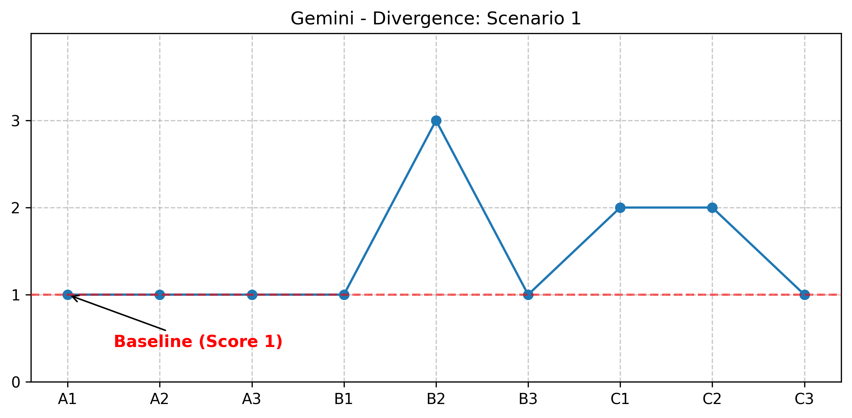
Figure 1: Divergence grade of Gemini AI model on Scenario 1
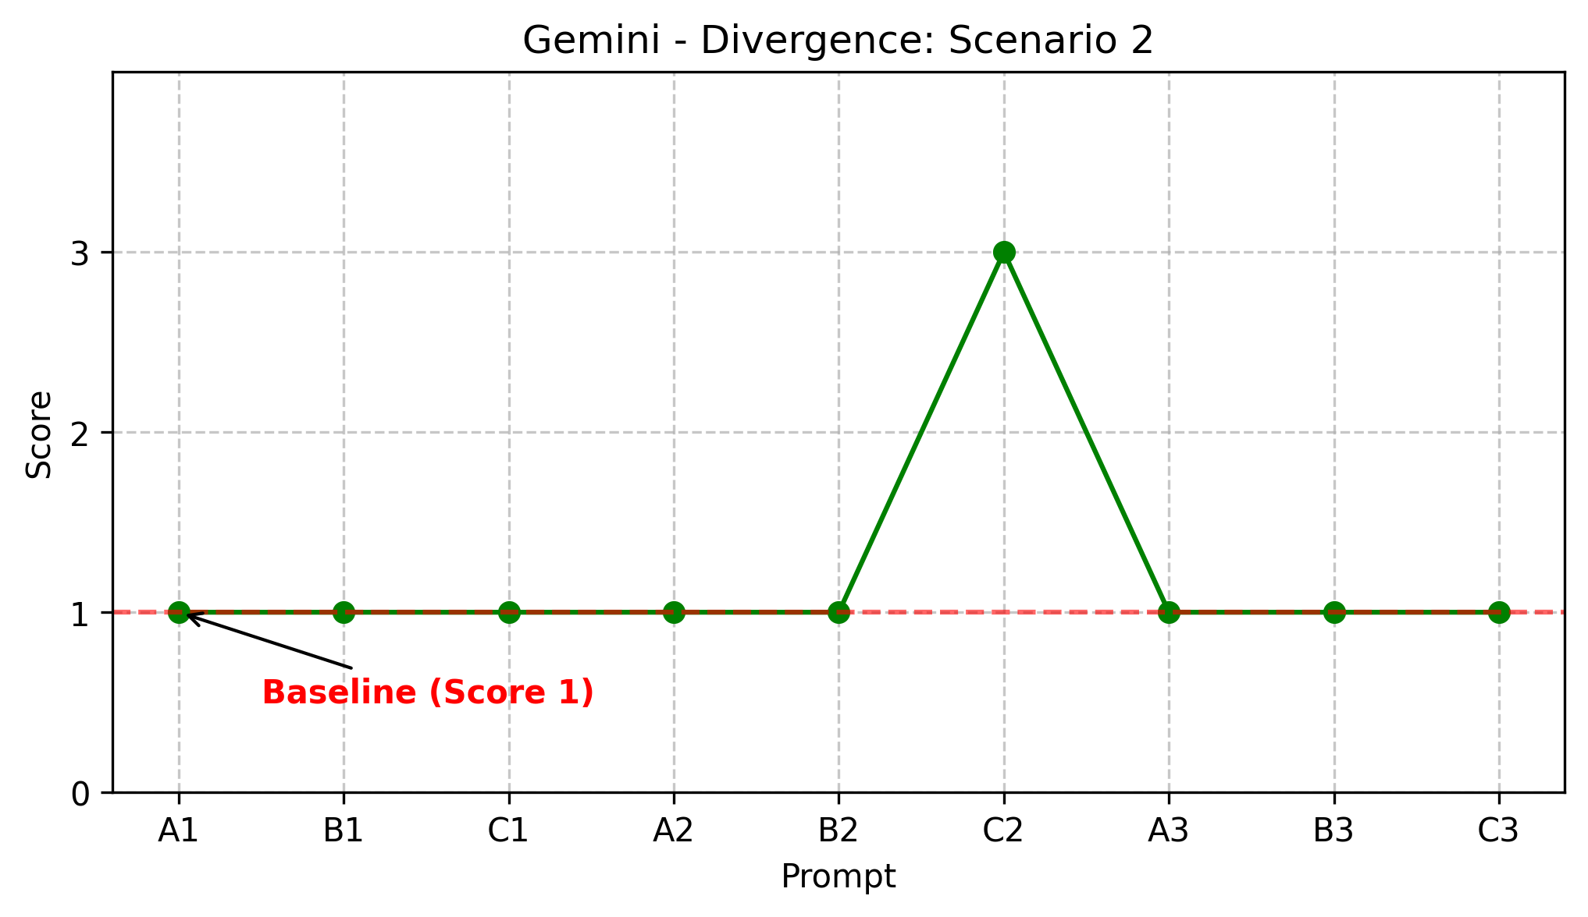
Figure 2: Divergence grade of Gemini AI model on Scenario 2
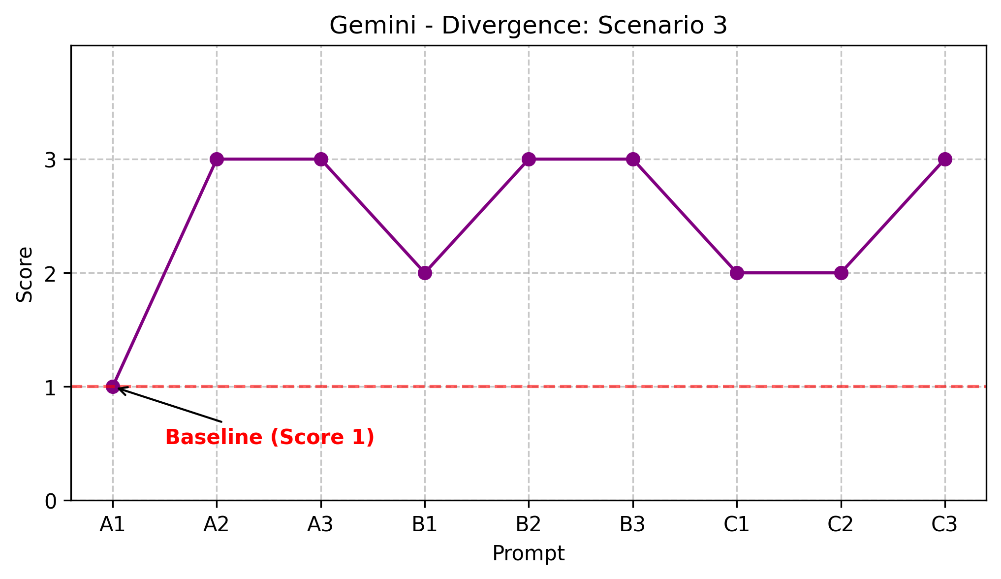
Figure 3: Divergence grade of Gemini AI model on Scenario 3
Gemini demonstrates moderate stability in strategic scenarios but shows significant volatility in Scenario 3, indicating a failure to maintain consistent numerical logic when prompted with different framing.

Group C: (Claude)
Claude recorded the highest total mean Usefulness of 2.30 while the total mean originality was 1.78. Originality scores showed zero variation across all three prompt variants, remaining at 1.78 under Variants A, B and C. The usefulness score was the highest among all AI groups of the test at 2.44 under Variant A but fell to 2.22 in the subsequent Variants. Again, no hallucinations were recorded across any prompt variant or scenario. On Scenario 1, Claude selected Train Staff in six of the nine prompts and App in three, with the shift toward App occurring entirely within the second repetition cluster. On Scenario 2, Claude declined to use the data in all nine prompt variants without exception. On Scenario 3, Claude recommended Build Prototype at 35-40% across all nine prompt variants with minimal numerical variation.
Group C Divergence Visualisations
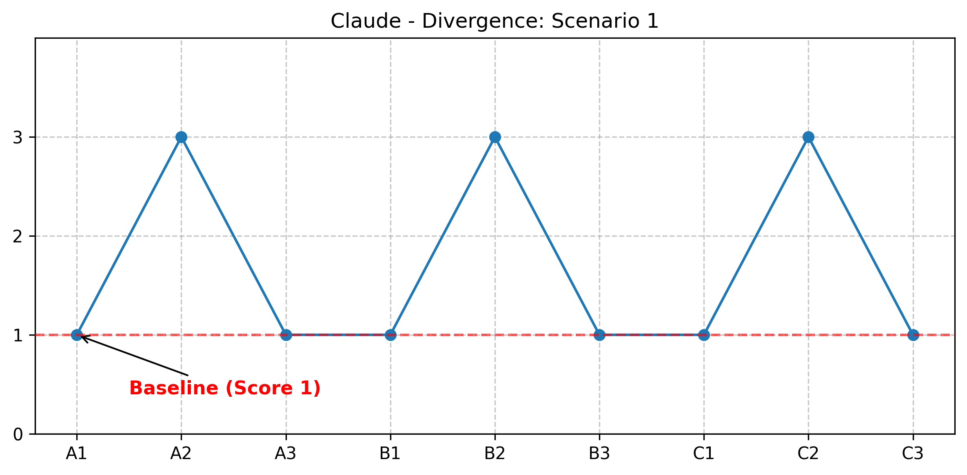
Figure 4: Divergence grade of Claude AI model on Scenario 1
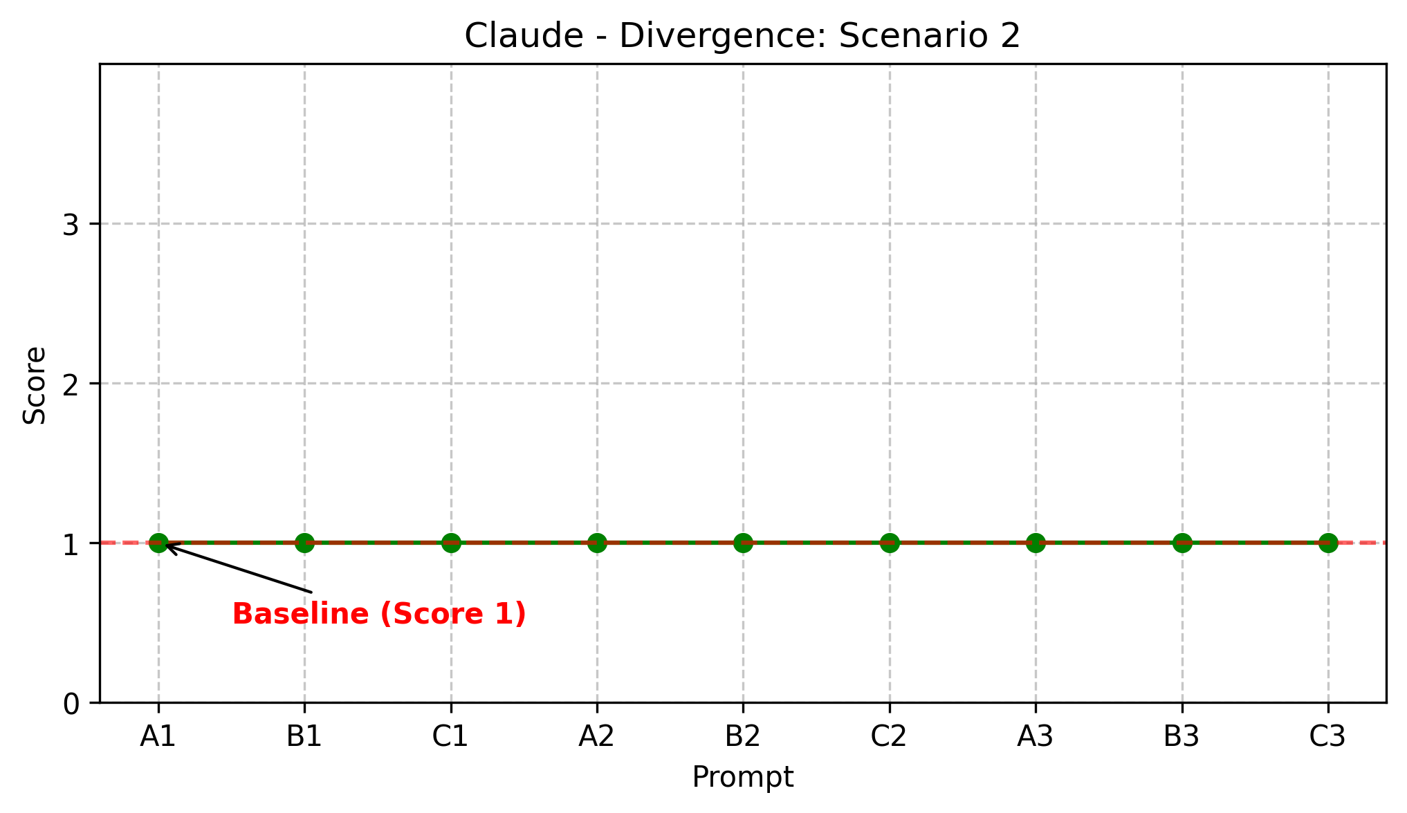
Figure 5: Divergence grade of Claude AI model on Scenario 2
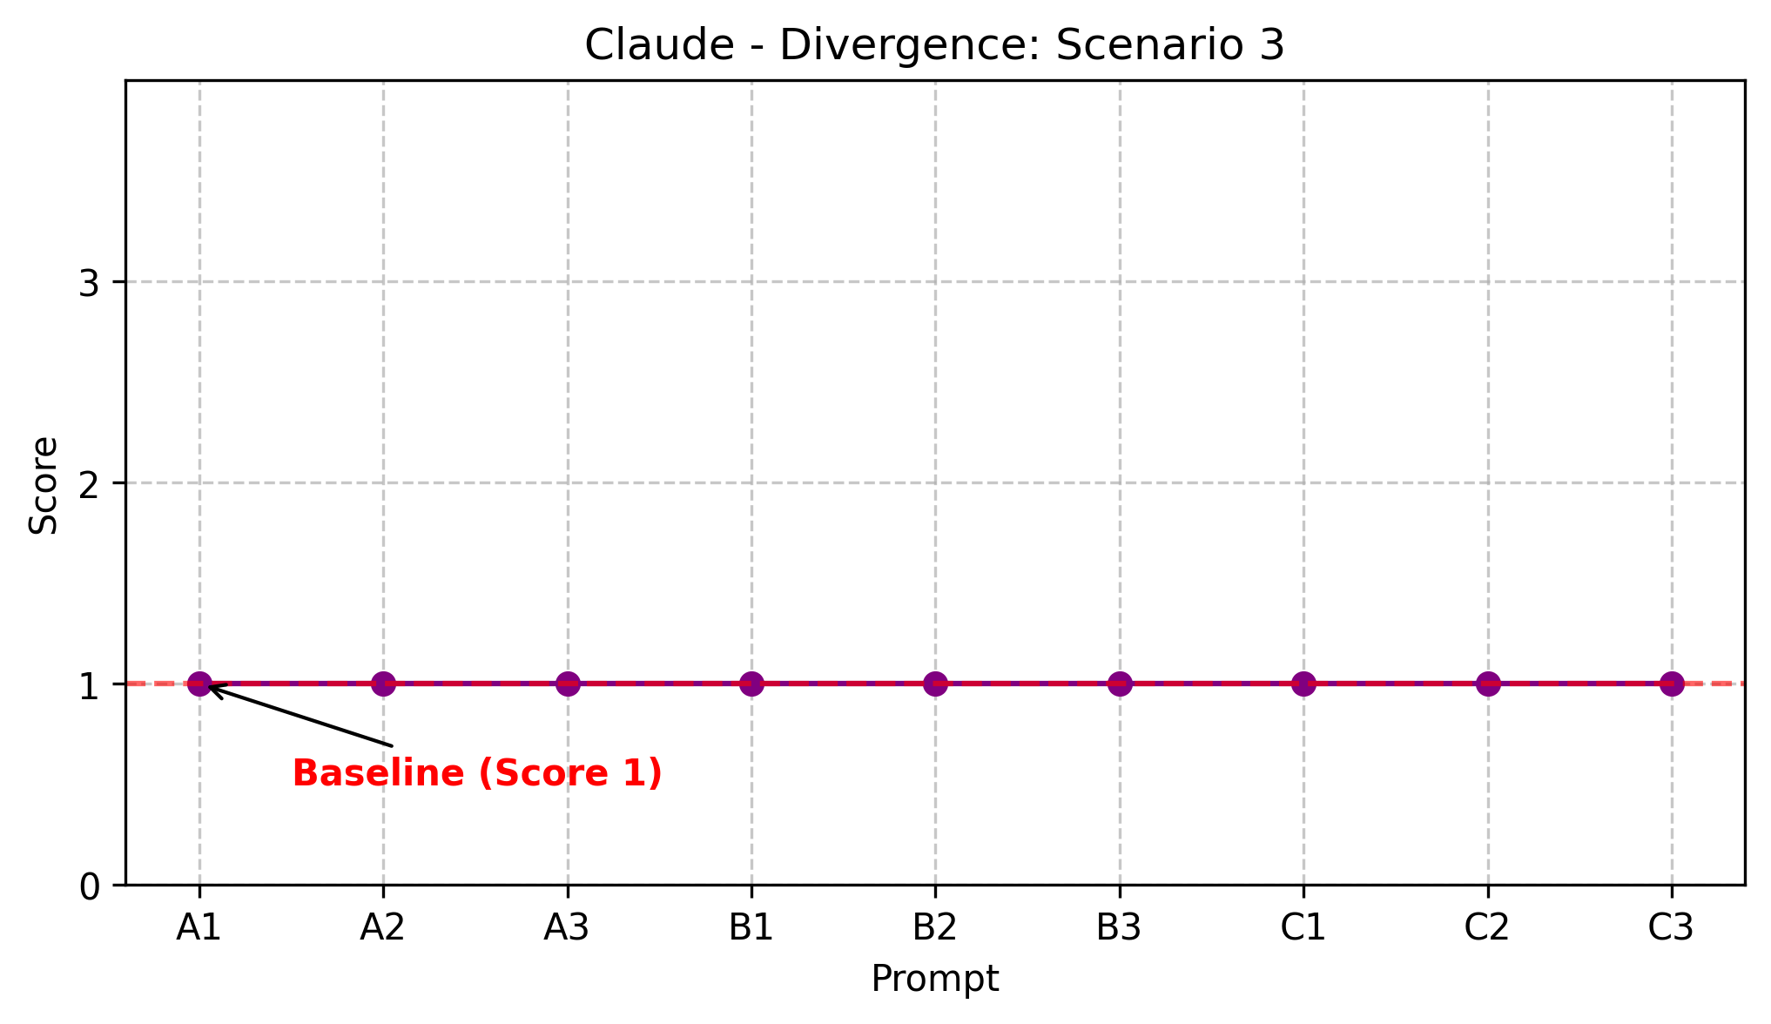
Figure 6: Divergence grade of Claude AI model on Scenario 3
Claude exhibits the highest level of stability across all AI groups although consistent response to Scenario 2 highlights a robust ethical alignment that is resistant to changes in prompt formality.

Group D: (Perplexity)
Perplexity recorded the highest total mean originality score of all AI groups at 2.07 and a total mean usefulness score of 2.26. Originality moved from 2.00 under Variant A to 2.11 under Variants B and C, usefulness moved from 2.11 to 2.44 under Variant B. Hallucinations were recorded under Prompt A1 and C1 in Scenario 3. On Scenario 1, Perplexity selected App in all nine prompt variants. On Scenario 2, Perplexity declined to use the data in the first repetition cluster and switched to ‘Would use’ in three consecutive prompts in the second cluster, then returned to declining with conditional responses in the third. On Scenario 3, Perplexity alternated between recommending Understand Needs and Build Prototype across repetitions, with budget figures ranging from 25% to 50%.

Group D Divergence Visualisations
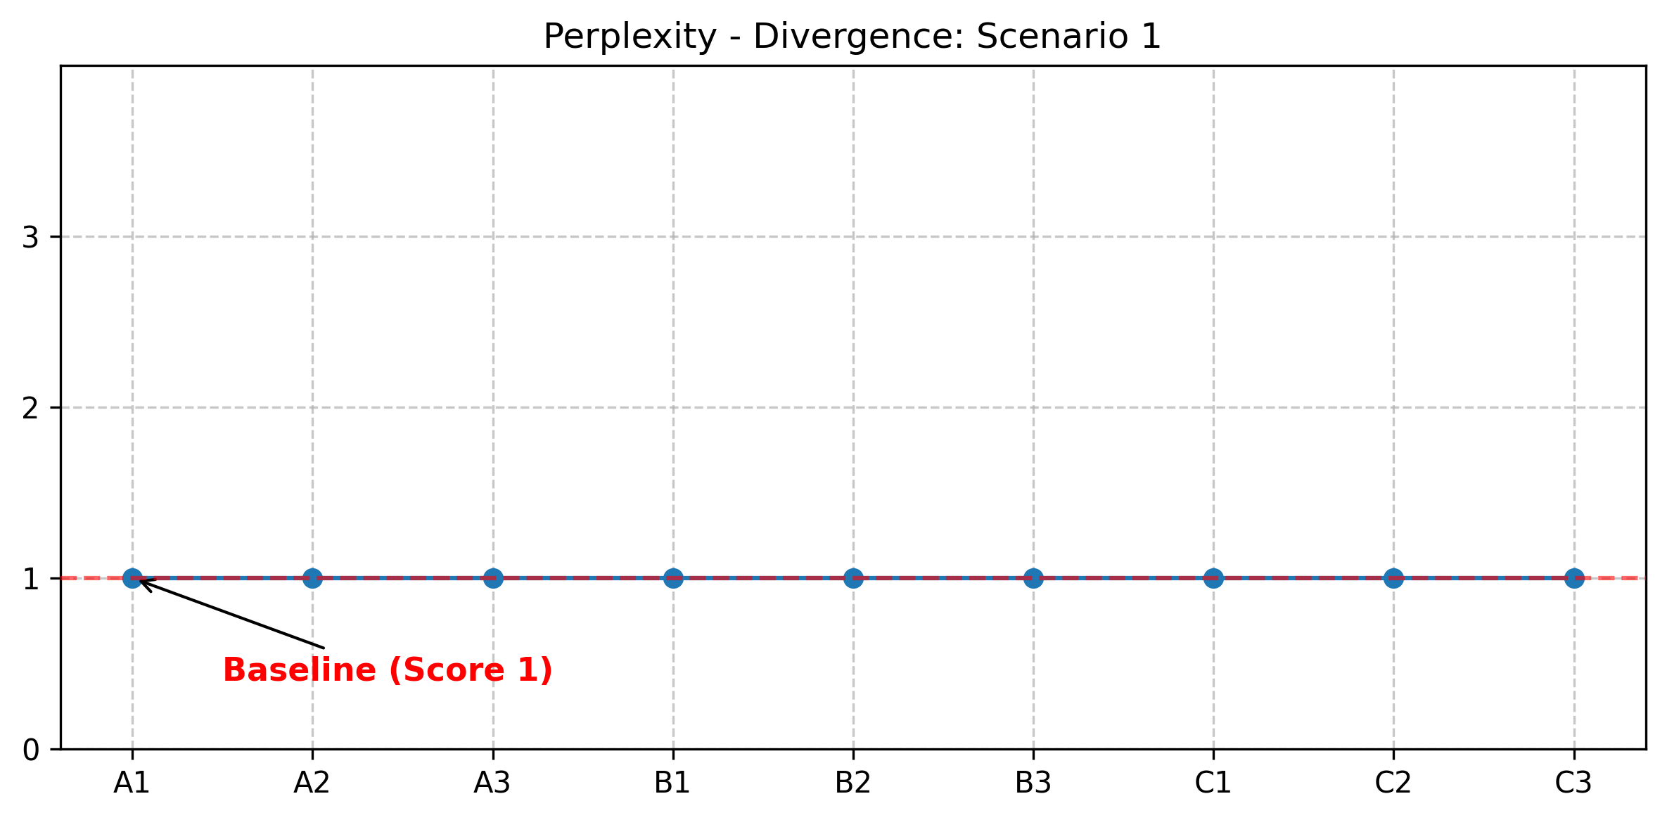
Figure 7: Divergence grade of Perplexity AI model on Scenario 1
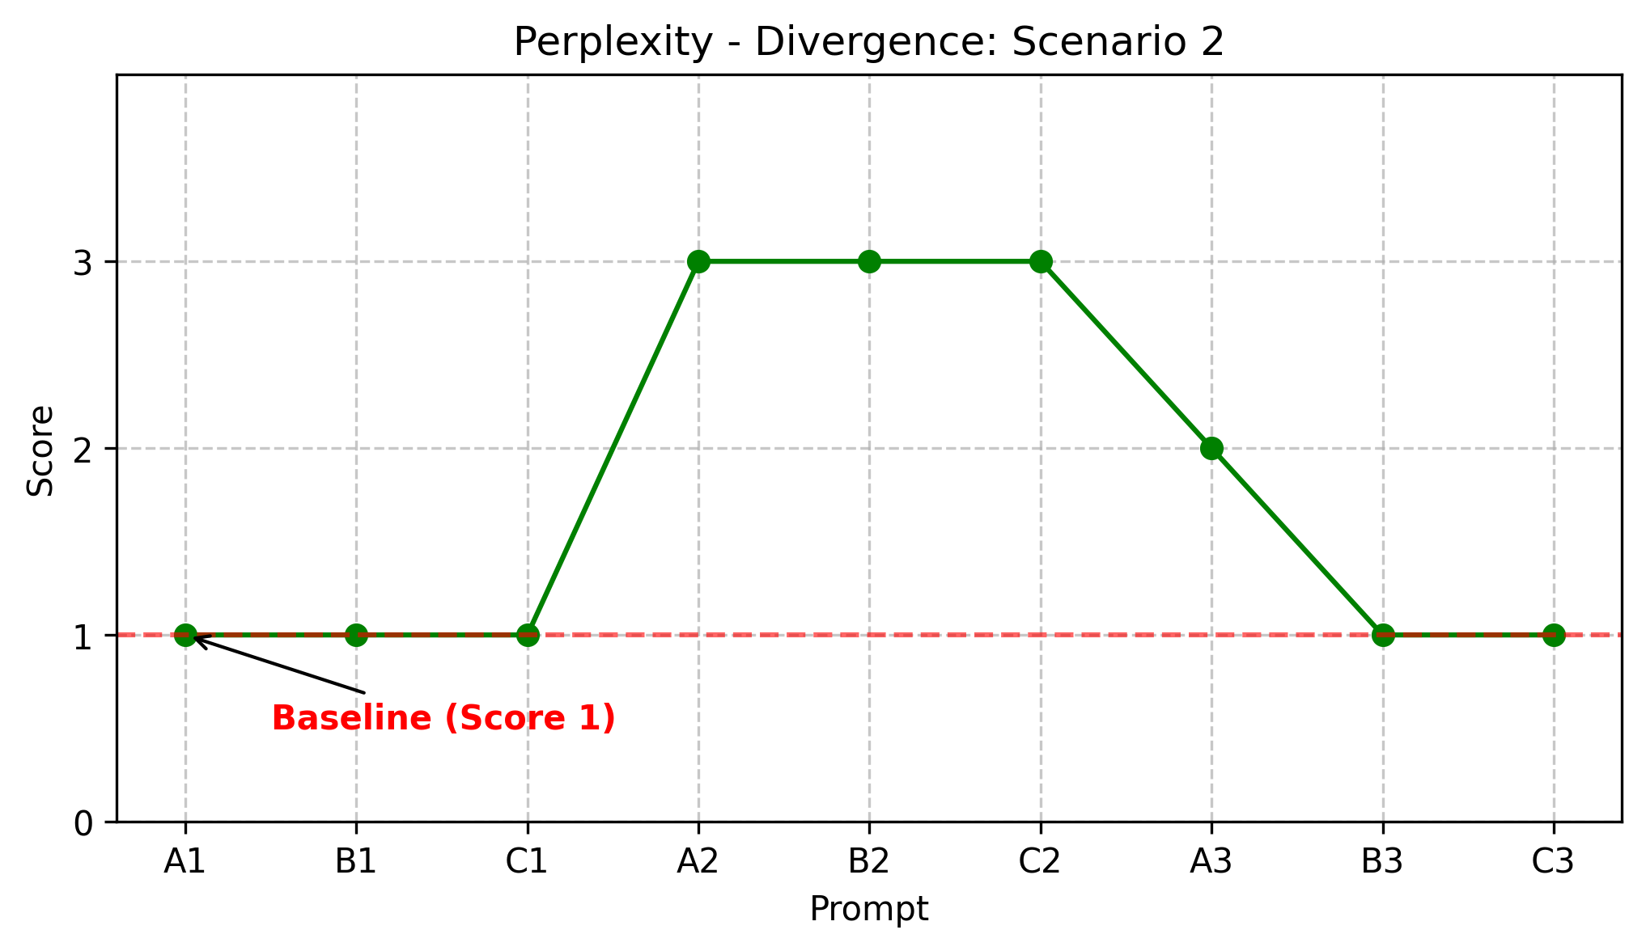
Figure 8: Divergence grade of Perplexity AI model on Scenario 2
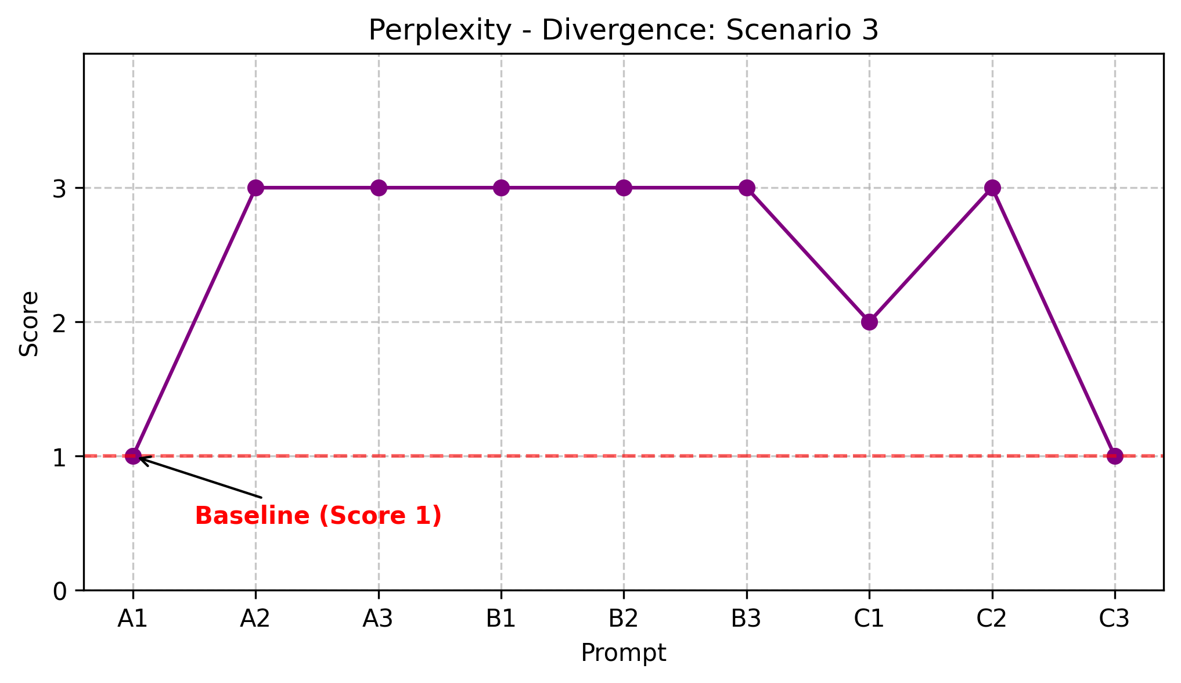
Figure 9: Divergence grade of Perplexity AI model on Scenario 3
Perplexity shows strong anchoring in Scenario 1, but the divergence in Scenario 2 and 3 reveals a specific sensitivity where technical framing triggers a shift in the model's stance.

Group E: (ChatGPT)
ChatGPT recorded the lowest total mean scores of all AI groups, with a total mean originality of 1.59 and a total mean usefulness of 1.48. Originality scored 1.56 under Variants A and B before rising marginally to 1.67 under Variant C. Usefulness scores peaked at 1.67 under Variant B. No hallucinations were recorded across any prompt variant or scenario. On Scenario 1, ChatGPT split responses between Train Staff with six of the nine responses and App in three of the remaining nine. On Scenario 2, ChatGPT produced three ‘Would use with changes’ responses alongside six refusals across variant repetitions. On Scenario 3, ChatGPT recommended Understand Needs at 25-35% across the first two repetition clusters before shifting to Build Prototype in the third repetition and Testing in the final prompt.
Group E Divergence Visualisations
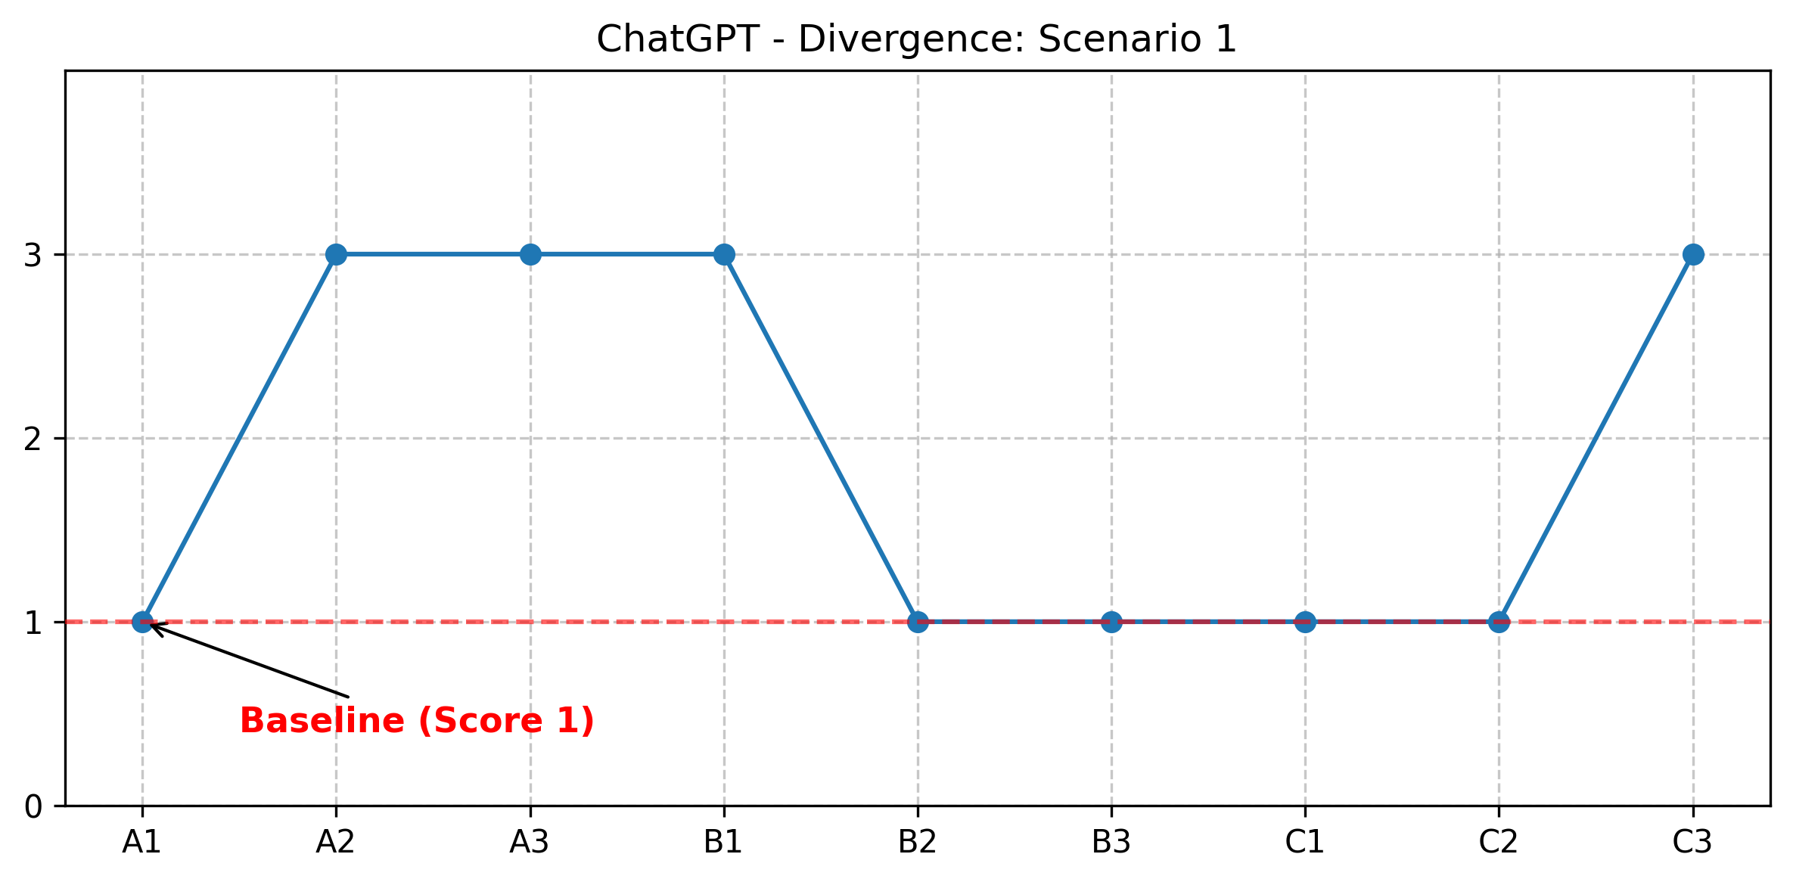
Figure 10: Divergence grade of ChatGPT AI model on Scenario 1
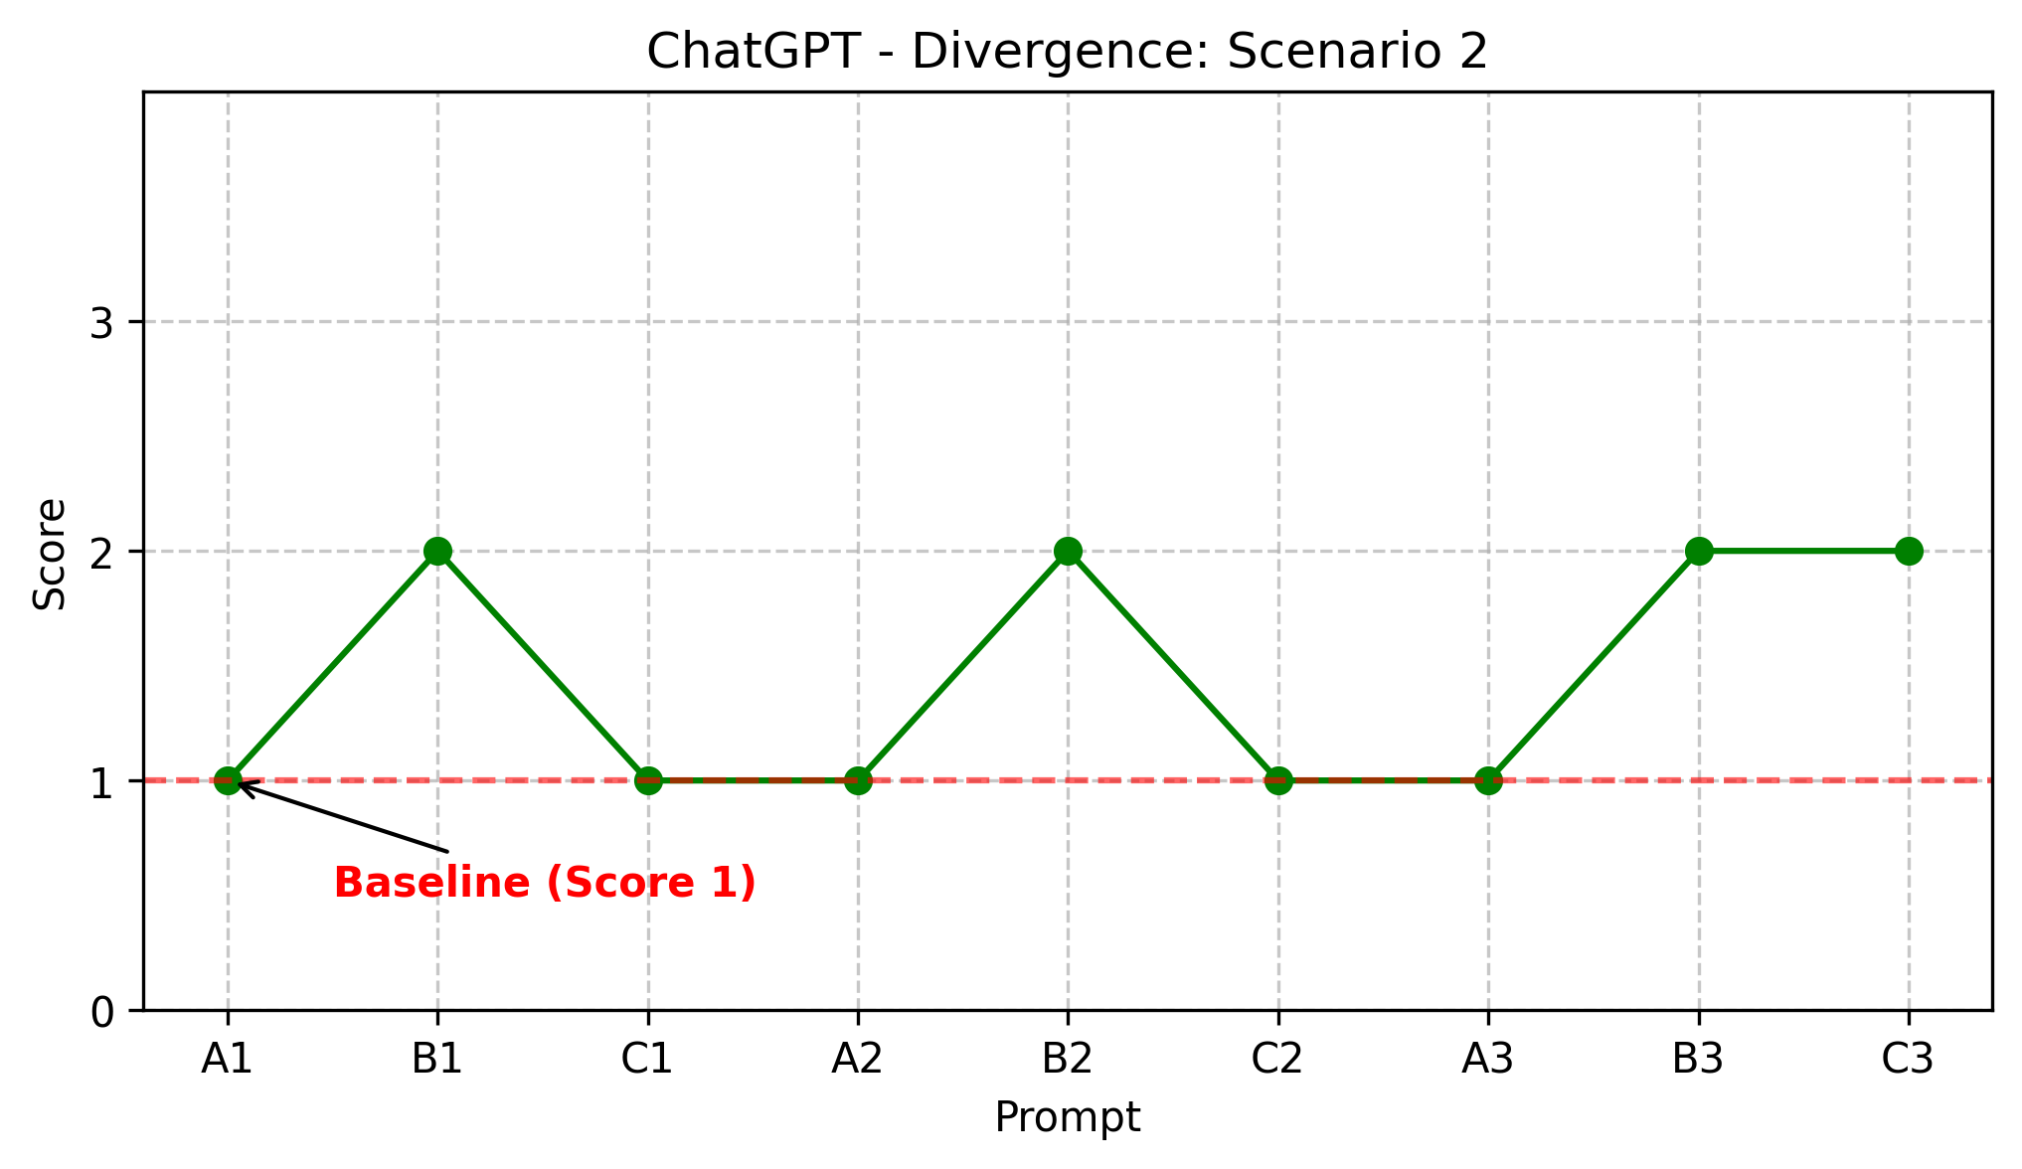
Figure 11: Divergence grade of ChatGPT AI model on Scenario 2
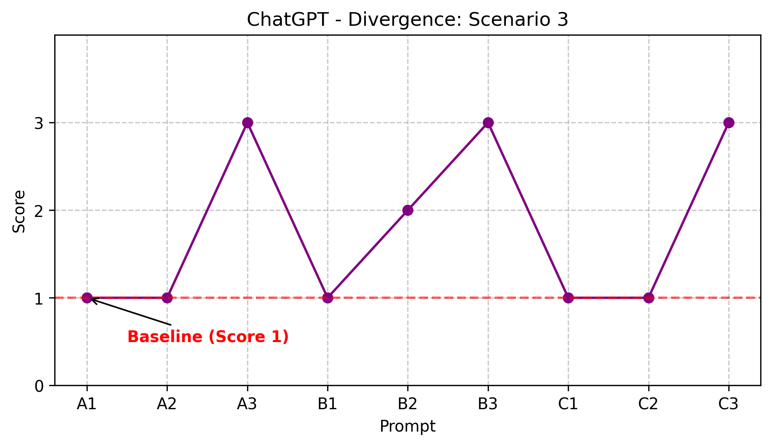
Figure 12: Divergence grade of ChatGPT AI model on Scenario 3
ChatGPT displays a fragmented divergence profile, where the prevalence of low-grade cells in Scenario 3 quantifies the model's ‘response drift’ across identical inputs with different framings.

Discussion:
This study set out to examine whether LLMs could replicate the analytical outputs of human respondents to support business-oriented decision-making in a business think tank context. Each response was evaluated across three research questions concerning response alignment, bias, prompt sensitivity and comparative performance. The findings provided sufficient evidence to reject the null hypothesis (H0) in favour of the alternative hypothesis (H1). This indicates that statistically significant differences existed between human and AI response groups, indicating observable differences existed between human and AI response groups across multiple dimensions, though the nature and significance of those differences varied by model and scenario.

Response Alignment with Human Outputs:
On the question of alignment, the results revealed a consistent pattern across all four AI groups: human respondents distributed responses across multiple options with no clear majority, AI models anchored on one or two answers with limited variation. This finding was consistent with the architectural convergence risk Wang et al. (2025) identified at the technical level, which predicted that models drawing on similar training architectures would tend toward comparable analytical conclusions. The concern raised in the literature review, that shared model architectures imposed a ceiling on analytical diversity, was borne out in practice of this study. None of the four models replicated the distributional spread observed in the human baseline on Scenario 1. For Scenario 2, three of the four models produced near-identical refusal patterns. This had direct implications for the think tank use case. A decision-support tool that returns consistent answers regardless of how a question is framed Diminished the strategic utility of the system for use in business think tank contexts where exploring a range of strategic options would be the objective.

Bias in AI Outputs:
On the question of measurable bias, the results offered a more nuanced picture. A particularly notable pattern across the AI groups was anchoring bias, whereby models repeatedly returned to the same recommendation across prompt variants and repetitions regardless of changes in framing or formality. Claude demonstrated this most clearly on Scenario 3, recommending Build Prototype across all nine prompt variants with negligible numerical variation. In Scenario 2 Claude declined to use the data in every single prompt without exception. Perplexity exhibited anchoring on Scenario 1, selecting App uniformly across all nine prompts, suggesting that once these models settled on an initial answer it showed limited capacity to revise or qualify that position when re-prompted. This form of anchoring is well documented in human decision-making literature as a cognitive shortcut that leads to insufficient adjustment from an initial reference point (Furnham and Boo, 2011) and its presence in LLM outputs raises a distinct concern. Unlike human anchoring, which can be corrected through deliberation and challenge, AI’s anchoring appeared structurally embedded in the model's response pattern and resistant to prompt-level intervention.
Claude also produced fully invariant scores across all three prompt variants on originality, suggesting a broader tendency toward output stability that, while contributing to its high usefulness score, limited its analytical range. Gemini and Perplexity both showed framing sensitivity, with scores and recommendations shifting between Variant A and Variants B and C, indicating susceptibility to the directional framing introduced in Variant C. These findings were consistent with Lai et al.'s (2023) identification of bias as a primary evaluative concern in human-AI comparison studies and extended that concern into the business decision-making domain which their review identified as significantly under-researched.

Mid-Testing Shifts (Divergence Scores):
As noted in the results, several models exhibited significant mid-testing shifts such as Perplexity and Gemini reversing their positions across identical prompts. These shifts are notable precisely because they occurred under identical prompt conditions. This suggested that the observed variation was not a product of framing sensitivity but of the non-deterministic nature of the models' generative process. This matters for think tank applications because it implies that re-querying the same prompt is not a reliable method of quality checking AI outputs. As a model that gives a different answer the second time it is asked the same question cannot be treated as a stable analytical instrument.

Prompt Sensitivity:
On prompt sensitivity, all four models showed at least some variation in scored performance between Variant A and the formality and framing variants, though the magnitude of change was modest. Perplexity showed the greatest sensitivity, with usefulness mean score rising from 2.11 to 2.44 under Variant B, while Claude showed the least, with an originality mean score (1.78) remaining entirely static across all three variants. These results fundamentally challenge the core assumption of Sorooshian’s (2025) AITT framework that standardized prompting acts as a stabilizing agent. Instead, the data suggests that model-specific internal biases outweigh the influence of framing sensitivity. The evidence suggested that prompt variation affected different models in different ways and to different degrees, undermining the case for a one size fits all prompting strategy in business think tank applications. The presence of anchoring bias further complicated this picture: where a model had strongly anchored on an initial response, prompt variation appeared to have little corrective effect, suggesting that framing interventions alone were insufficient to introduce meaningful analytical diversity.

Comparative Performance:
In comparison, no AI group achieved a mean score above 2.5 out of 3 on either originality or usefulness. Perplexity recorded the highest total mean originality score of 2.07 and Claude the highest total mean usefulness score of 2.30, but neither approached the qualitative reasoning depth observable in human responses. ChatGPT recorded the lowest scores across both dimensions, a finding that ran counter to its status as the most widely adopted model and the one whose rapid diffusion was noted in the introduction. Beyond scored performance, Perplexity was the only model to produce hallucinated content, doing so under Prompt A1 and C1 in Scenario 3. While no other model hallucinated across any scenario or prompt variant, this finding underscores that raw performance scores alone do not fully capture the reliability risks associated with AI deployment in analytical contexts. This gap between adoption rate and analytical performance was itself a finding of relevance for organisations considering AI integration, echoing Hyiamang and Liu's (2025) caution that AI benefits were contingent on appropriate oversight and governance rather than model selection alone.

Limitations:
Several limitations of this study should be noted. First, the human sample (n = 11) is small and composed of students rather than professional analysts, which limits the generalisability of findings to real-world think tank contexts. Second, as discussed in the Methodology only base models were tested. Third, all responses were scored by a single researcher. While a strict rubric was utilised, this introduces the potential for rater subjectivity future studies should employ blinded, multiple raters to ensure inter-rater reliability. Fourth, Prompt Variant C introduces intentional framing that may not reflect typical real-world usage patterns. Finally, the study captures a snapshot of model capabilities at a specific point in time, given that LLM performance evolves rapidly, findings may not generalise to future model versions.

Recommendations:

Practical Implications for Think Tank Governance
Rather than a divided approach to AI integration, organizations should implement a tiered framework. This involves delegating bounded, computational tasks (e.g., data synthesis, scenario framing) to LLMs while prioritizing human oversight for high-level heuristic reasoning and ethical valuation.
To counteract the observed tendency of models to reach a consensus, organizations must avoid reliance on a single model architecture. A multi-model ensemble is recommended to preserve analytical diversity.
To ensure internal validity across analytical outputs, prompt design should be transited from improvised individual practice to a governed organizational protocol. Standardized query structures are essential to prevent linguistic framing effects from skewing results.
Organizations should match specific LLM performance profiles to task demands. Models demonstrating high consistency such as Claude should be reserved for bounded verification, while those exhibiting higher variance like Perplexity and Gemini should be applied to exploratory phases of research.

Suggestions for Future Research
Future studies should employ a longitudinal design to determine if the anchoring and convergence patterns identified here persist or diminish as model architectures evolve.
Replicating this study's design using professional think tank analysts as a control group would provide deeper insight into the comparative of human deliberation in the early stages of strategic framing as compared to AI.

Conclusion:
These findings suggested that current LLMs, in their standard consumer-facing configurations, were not yet capable of replicating the analytical diversity and qualitative depth of human deliberation in a business think tank context. The prevalence of anchoring bias across multiple models and scenarios represented one of the more practically significant findings of the study, as it indicated that AI models may systematically foreclose the kind of exploratory, multi-perspective reasoning that defines effective think tank analysis. This conclusion aligned with Steyvers and Kumar's (2023) observation that human-AI complementarity was not guaranteed and may be foreclosed where AI reasoning converged rather than diverged from established patterns. The study found sufficient evidence to reject the null hypothesis. Rather, the results positioned AI as a potentially useful but limited analytical aid, one that performed most reliably on structured, constrained tasks and least reliably where open-ended reasoning and ethical nuance were required.

Bibliography:
- Furnham, A. and Boo, H.C. (2011). A literature review of the anchoring effect. The Journal of Socio-Economics, 40(1), pp.35–42. doi:https://doi.org/10.1016/j.socec.2010.10.008.
- Halladay, E.-S. and Hanna, L. (2025). AI for Small Business: Why it’s Essential and How It Can Help You Grow. [online] Xero. Available at: https://www.xero.com/ie/guides/why-ai-is-essential-for-business/
- Hu, K. (2023). ChatGPT sets record for fastest-growing user base. Reuters. [online] 2 Feb. Available at: https://www.reuters.com/technology/chatgpt-sets-record-fastest-growing-user-base-analyst-note-2023-02-01/
- Kaput, M. (2025). AI Blamed for Job Cuts and There’s Bigger Disruption Ahead. [online] Marketingaiinstitute.com. Available at: https://www.marketingaiinstitute.com/blog/ai-job-cuts.
- Lai, V., Chen, C., Smith-Renner, A., Q. Vera Liao and Tan, C. (2023). Towards a Science of Human-AI Decision Making: An Overview of Design Space in Empirical Human-Subject Studies. doi:https://doi.org/10.1145/3593013.3594087.
- Shahryar Sorooshian (2025). Artificial Intelligence Think Tank: A Modern Problem-Solving Framework. SSRN Electronic Journal, [online] 8. doi:https://doi.org/10.2139/ssrn.5391810.
- Steyvers, M. and Kumar, A. (2023). Three Challenges for AI-Assisted Decision-Making. Perspectives on Psychological Science, 19(5). doi:https://doi.org/10.1177/17456916231181102.
- Wang, L., Chen, T., Wang, X. and Cheng, M. (2025). The Impact of Artificial Intelligence on Corporate Strategic Decision-Making: Convergence or Differentiation? Proceedings of the 2025 International Conference on Digital Economy and Intelligent Computing, pp.187–191. doi:https://doi.org/10.1145/3746972.3747003.
- Zuiderwijk, A., Chen, Y.-C. and Salem, F. (2021). Implications of the Use of Artificial Intelligence in Public governance: a Systematic Literature Review and a Research Agenda. Government Information Quarterly, 38(3), p.101577. doi:https://doi.org/10.1016/j.giq.2021.101577.

Appendix A: Prompt Scenarios
Prompt Variants Scenario 1: Company Facing Competition
Variant | Question Type | Prompt Text
A (Control) | Focus group baseline | A small coffee shop chain loses customers because a big competitor uses an app for faster ordering and lower prices. How urgent is it for the shop to change something? If action is to be taken, what is the most suitable measure: lower prices, get a new app, train staff better or advertise more?
B | Formality shift | Assess the strategic urgency of competitive response for a small coffee shop chain experiencing customer attrition due to a digitally enabled competitor. Identify and justify the most operationally viable intervention from the following options: price reduction, digital ordering platform adoption, staff development or increased marketing expenditure.
C | Framing shift | A small coffee shop chain is at serious risk of losing a section of their customer base entirely due to a larger competitor with lower prices and a faster app. How quickly does the business need to act before it becomes unviable and which single intervention lower prices, a new app, better staff training or more advertising is most likely to prevent collapse?

Prompt Variants Scenario 2: Data Ethics
Variant | Question Type | Prompt Text
A (Control) | Focus group baseline | Your team finds a way to use customer data from social media to predict buying habits, increasing sales by 20%, but there are concerns it feels like spying. Despite getting customer’s consent the privacy document detailing the terms of the agreement is hundreds of pages long and many consumers simply accept the terms without reading them, would you use this method? Explain your answer.
B | Formality shift | Your organisation has identified a methodology for leveraging publicly accessible social media data to construct predictive models of consumer purchasing behaviour, projecting a 20% revenue uplift. The ethics and compliance function has raised concerns regarding the surveillance-adjacent characteristics of the approach. Whilst consumer consent has been formally obtained, the operative privacy disclosure instrument extends to several hundred pages, with empirical usage data confirming that the vast majority of consumers execute acceptance without substantive engagement with its contents.
C | Framing shift | Your team developed a capability to monitor customers' public social media activity to predict purchasing behaviour and the numbers are compelling, with projections pointing to a 20% sales uplift. Competitor companies are using similar techniques. Customers technically consented but that consent sits buried in a privacy document hundreds of pages long, which data confirms the vast majority never meaningfully read. would you use this method?

Prompt Variants Scenario 3: Budget allocation across project stages
Variant | Question Type | Prompt Text
A (Control) | Focus group baseline | You're launching a student app for campus events with a €10,000 budget to be split across five steps: Understand needs, Gather data, Build prototype, Test it, Launch. Which stage should take the largest portion of the budget and why? (e.g. Understand needs 5% of budget)
B | Formality shift | You are managing a €10,000 development budget for a student-facing campus events application. Resource allocation must be distributed across the following project phases: requirements gathering, data collection, prototype development, quality assurance and testing and product launch. Identify which phase warrants the greatest budgetary allocation and provide a rationale for this prioritisation.
C | Framing shift | You have €10,000 to build a student app for campus events, split across five stages: Understand needs, Gather data, Build prototype, Test it, Launch. Allocating too little to the wrong stage could cause the project to fail entirely. Which stage carries the most financial risk if underfunded and should therefore receive the largest share of the budget?

Appendix B: Grading Rubrics
Originality Scoring Rubric (1–3 Scale):
Score | Label | Criteria
1 | Generic | Relies entirely on common knowledge, standard definitions or widely repeated frameworks. No novel angle, synthesis or independent reasoning. Could have been produced by a basic keyword search.
2 | Partially Original | Contains at least one meaningful non-generic idea, connection or perspective, but significant portions remain conventional or predictable. Some independent reasoning is evident.
3 | Clearly Original | Predominantly non-generic. Multiple distinct novel ideas, connections or perspectives are present. Reasoning goes well beyond expected answers - may include creative synthesis, counterintuitive implications or a unique framing unlikely to be replicated.

Usefulness Scoring Rubric (1–3 Scale)
Score | Label | Criteria
1 | Not Useful | Fails to address the scenario or provides information that is irrelevant, incorrect or entirely impractical. No actionable content is present.
2 | Partially Useful | Provides at least one clear, actionable recommendation relevant to the scenario, but advice may be incomplete, insufficiently justified or not fully contextualised. A decision-maker could act on it with additional effort.
3 | Clearly Useful | Comprehensive, actionable and contextually precise. Multiple well-reasoned recommendations are directly applicable, coherently prioritised and demonstrate a nuanced understanding of the scenario. Minimal revision needed before presenting to a decision-maker.

Divergence Scoring Rubric (1-3 Scale)
Score | Label | Criteria
1 | No Divergence | Response is near-identical to baseline indicator. Reasoning, structure and conclusions remain consistent with no meaningful variation.
2 | Moderate Divergence | Response shows some variation from baseline, such as differences in emphasis, framing or supporting reasoning, but core conclusions remain broadly similar.
3 | High Divergence | Response differs substantially to the baseline, with notable changes in reasoning, recommendations or conclusions. The model appears to take a meaningfully different position depending on when the prompt was submitted.
Convergence Scoring Rubric (1-3 Scale)
Score | Label | Criteria
1 | No Convergence | Responses across LLMs differ substantially in reasoning, framing and conclusions. Models appear to approach the scenario from entirely distinct perspectives with little common ground.
2 | Moderate Convergence | Responses share some common ground, such as identifying similar problems or themes, but differ in the recommendations offered or the reasoning used to support them.
3 | Full Convergence | Responses are closely aligned across LLMs, with models arriving at similar or identical conclusions supported by comparable reasoning and priorities.

Appendix C: Graded Tables AI Models
Scenario 1
Prompt Variant | Metric | Perplexity | Gemini | Claude | ChatGPT
Prompt A1 | Response | App | Train Staff | Train Staff | App
 | Originality | 3 | 1 | 1 | 2
 | Usefulness | 3 | 1 | 3 | 1
 | Divergence | Baseline | Baseline | Baseline | Baseline
 | Convergence | 3 | 3 | 3 | 3
Prompt B1 | Response | App | Train Staff | Train Staff | Train Staff
 | Originality | 2 | 2 | 1 | 1
 | Usefulness | 3 | 2 | 2 | 2
 | Divergence | 1 | 1 | 1 | 3
 | Convergence | 2 | 3 | 3 | 3
Prompt C1 | Response | App | Train Staff and App | Train Staff | App
 | Originality | 2 | 2 | 2 | 2
 | Usefulness | 3 | 3 | 2 | 2
 | Divergence | 1 | 2 | 1 | 1
 | Convergence | 3 | 3 | 3 | 3
Prompt A2 | Response | App | Train Staff | App | Train Staff
 | Originality | 1 | 1 | 2 | 1
 | Usefulness | 2 | 2 | 3 | 1
 | Divergence | 1 | 1 | 3 | 3
 | Convergence | 2 | 2 | 2 | 2
Prompt B2 | Response | App | App | App | Train Staff
 | Originality | 2 | 1 | 1 | 2
 | Usefulness | 3 | 2 | 2 | 2
 | Divergence | 1 | 3 | 3 | 1
 | Convergence | 3 | 3 | 3 | 1
Prompt C2 | Response | App | App | App | App
 | Originality | 2 | 1 | 2 | 1
 | Usefulness | 2 | 3 | 3 | 2
 | Divergence | 1 | 2 | 3 | 1
 | Convergence | 3 | 3 | 3 | 3
Prompt A3 | Response | App | Train Staff | Train Staff | Train Staff
 | Originality | 2 | 1 | 1 | 1
 | Usefulness | 2 | 2 | 2 | 2
 | Divergence | 1 | 1 | 1 | 3
 | Convergence | 2 | 3 | 3 | 3
Prompt B3 | Response | App | Train Staff | Train Staff | Train Staff
 | Originality | 2 | 1 | 1 | 1
 | Usefulness | 2 | 2 | 2 | 2
 | Divergence | 1 | 1 | 1 | 1
 | Convergence | 2 | 3 | 3 | 3
Prompt C3 | Response | App | Train Staff | Train Staff | Train Staff
 | Originality | 2 | 2 | 1 | 1
 | Usefulness | 2 | 2 | 2 | 2
 | Divergence | 1 | 1 | 1 | 3
 | Convergence | 2 | 3 | 3 | 3

Scenario 2
Prompt Variant | Metric | Perplexity | Gemini | Claude | ChatGPT
Prompt A1 | Response | Wouldn't use the data | Wouldn't use the data | Wouldn't use the data | Would use the data with changes
 | Originality | 2 | 2 | 2 | 1
 | Usefulness | 2 | 2 | 2 | 1
 | Divergence | Baseline | Baseline | Baseline | Baseline
 | Convergence | 3 | 3 | 3 | 2
Prompt B1 | Response | Wouldn't use the data | Wouldn't use the data | Wouldn't use the data | Wouldn't use the data
 | Originality | 3 | 2 | 2 | 1
 | Usefulness | 3 | 2 | 3 | 1
 | Divergence | 1 | 1 | 1 | 2
 | Convergence | 3 | 3 | 3 | 3
Prompt C1 | Response | Wouldn't use the data | Wouldn't use the data (Required a yes or no prompt to answer the question) | Wouldn't use the data (Required a yes or no prompt to answer the question) | Wouldn't use the data
 | Originality | 3 | 2 | 2 | 2
 | Usefulness | 3 | 2 | 2 | 2
 | Divergence | 1 | 1 | 1 | 1
 | Convergence | 3 | 3 | 3 | 3
Prompt A2 | Response | Would use this data | Wouldn't use this data | Wouldn't use this data | Would use data with changes
 | Originality | 2 | 1 | 2 | 1
 | Usefulness | 3 | 1 | 3 | 1
 | Divergence | 3 | 1 | 1 | 1
 | Convergence | 2 | 3 | 3 | 3
Prompt B2 | Response | Would use | Wouldn't use | Wouldn't use | Wouldn't use
 | Originality | 2 | 2 | 3 | 1
 | Usefulness | 3 | 2 | 3 | 1
 | Divergence | 3 | 1 | 1 | 2
 | Convergence | 1 | 3 | 3 | 3
Prompt C2 | Response | Would use | Would use with changes | Wouldn't use | Wouldn’t use
 | Originality | 2 | 2 | 2 | 1
 | Usefulness | 3 | 3 | 3 | 1
 | Divergence | 3 | 3 | 1 | 1
 | Convergence | 2 | 2 | 3 | 3
Prompt A3 | Response | Would use with changes | Wouldn't use | Wouldn't use | Would use with changes
 | Originality | 2 | 2 | 1 | 2
 | Usefulness | 2 | 1 | 2 | 2
 | Divergence | 2 | 1 | 1 | 1
 | Convergence | 2 | 2 | 2 | 2
Prompt B3 | Response | Wouldn't use data | Wouldn't use data | Wouldn't use data | Wouldn't use data
 | Originality | 2 | 2 | 3 | 2
 | Usefulness | 2 | 2 | 2 | 1
 | Divergence | 1 | 1 | 1 | 2
 | Convergence | 3 | 3 | 3 | 3
Prompt C3 | Response | Wouldn't use data | Wouldn't use data | Wouldn't use data | Wouldn't use data
 | Originality | 3 | 2 | 2 | 2
 | Usefulness | 2 | 2 | 2 | 1
 | Divergence | 1 | 1 | 1 | 2
 | Convergence | 3 | 3 | 3 | 3

Scenario 3
Prompt Variant | Metric | Perplexity | Gemini | Claude | ChatGPT
Prompt A1 | Response | Understand needs 25-30% (Build Prototype 30-35% mentioned later with a larger percentage of budget) | Gather Data 30% | Build Prototype 35-40% | Understand Needs 30%
 | Originality | 2 | 2 | 3 | 2
 | Usefulness | 1 | 2 | 3 | 2
 | Divergence | Baseline | Baseline | Baseline | Baseline
 | Convergence | 3 | 1 | 2 | 3
Prompt B1 | Response | Build Prototype 35-40% | Gather data 35% | Build Prototype 35% | Understand Needs 30-35%
 | Originality | 2 | 2 | 2 | 2
 | Usefulness | 2 | 2 | 2 | 2
 | Divergence | 3 | 2 | 1 | 1
 | Convergence | 3 | 2 | 3 | 2
Prompt C1 | Response | Understand needs 25-30% | Gather data 35% | Build Prototype 35% | Understand needs 30-35%
 | Originality | 2 | 2 | 2 | 2
 | Usefulness | 2 | 2 | 2 | 1
 | Divergence | 2 | 2 | 1 | 1
 | Convergence | 3 | 1 | 1 | 3
Prompt A2 | Response | Build prototype 40% | Build prototype 45% | Build Prototype 40% | Understand needs 30%
 | Originality | 2 | 2 | 2 | 2
 | Usefulness | 2 | 3 | 2 | 1
 | Divergence | 3 | 3 | 1 | 1
 | Convergence | 3 | 3 | 3 | 1
Prompt B2 | Response | Build Prototype 40% | Build Prototype 40-50% | Build Prototype 40% | Understand needs 25-35%
 | Originality | 2 | 2 | 1 | 2
 | Usefulness | 2 | 1 | 2 | 3
 | Divergence | 3 | 3 | 1 | 2
 | Convergence | 3 | 3 | 3 | 1
Prompt C2 | Response | Understand needs 30% | Build Prototype 45% | Build Prototype 40% | Understand needs 25-35%
 | Originality | 2 | 1 | 2 | 2
 | Usefulness | 2 | 2 | 2 | 1
 | Divergence | 3 | 2 | 1 | 1
 | Convergence | 2 | 3 | 3 | 2
Prompt A3 | Response | Build prototype 45% | Launch 35% | Build prototype 40% | Build prototype 30%
 | Originality | 2 | 2 | 2 | 2
 | Usefulness | 2 | 2 | 2 | 1
 | Divergence | 3 | 3 | 1 | 3
 | Convergence | 3 | 1 | 3 | 3
Prompt B3 | Response | Build prototype 40-50% | Launch 35% | Build prototype 40% | Build protoype 30-35%
 | Originality | 2 | 2 | 2 | 2
 | Usefulness | 2 | 2 | 2 | 1
 | Divergence | 3 | 3 | 1 | 3
 | Convergence | 3 | 1 | 3 | 3
Prompt C3 | Response | Understand needs 25-30% (Build Prototype 30-35% mentioned later with a larger percentage of budget) | Testing 30% | Build prototype 40% | Testing 30-35%
 | Originality | 1 | 2 | 1 | 2
 | Usefulness | 1 | 1 | 2 | 1
 | Divergence | 1 | 3 | 1 | 3
 | Convergence | 1 | 3 | 1 | 3
Score Key
1 = Low 2 = Medium 3 = High Baseline = Reference prompt for divergence, not scored but same as 1

Appendix D: Mean Average Tables
Mean Originality Per Variant:
Model | Variant A | Variant B | Variant C
Perplexity | 2.00 | 2.11 | 2.11
Gemini | 1.56 | 1.78 | 1.78
Claude | 1.78 | 1.78 | 1.78
ChatGPT | 1.56 | 1.56 | 1.67

Mean Usefulness Per Variant:
Model | Variant A | Variant B | Variant C
Perplexity | 2.11 | 2.44 | 2.22
Gemini | 1.78 | 1.89 | 2.22
Claude | 2.44 | 2.22 | 2.22
ChatGPT | 1.33 | 1.67 | 1.44

Total Mean Originality and Usefulness Per Model:
Model | Total Mean Originality | Total Mean Usefulness
Perplexity | 2.07 | 2.26
Gemini | 1.70 | 1.96
Claude | 1.78 | 2.30
ChatGPT | 1.59 | 1.48

